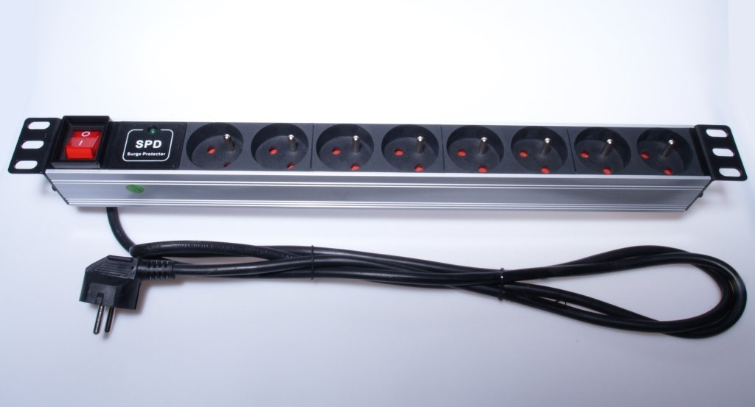

Power distribution Unit 1U for 19" Rack, 8x230V, 2m cable. switch, surge protection

Appearance
Size: 19'' 1U
Shell: Aluminum-alloy Shell
Control: Switch

Input characteristics
Rated input voltage: 250VAC 50/60Hz
Input standard: DIN49441
Power Cord: 2.0M (3x1.5mm2)
Max input current: 16A

Output characteristics
Socket standard: NFC61-314
Output quantity: 8
Rating output voltage: 250VAC 50/60Hz
Max output current: 16A

