U S E R M A N U A L

HDMI 2.0 Repeater 4K
(Support 4K and up to 30m)

Model No：HDRE01-V2.0

Enjoy the vivid world !
Introduce

HDMI 2.0 Repeater:

This HDMI repeater can realize signal enhancement by signal equaliztion and reorganization, so that the signal can be transmitted to longer distance. In addition,this product is also built-in IR-RX extension function, the infrared code be sent to splitter IR-TX terminal via HDMI cable to remotely control the signal source. The Resolution of this HDMI repeater can be up to:3840x2160/60Hz.
The max distance is up to 30m.
Product photos:

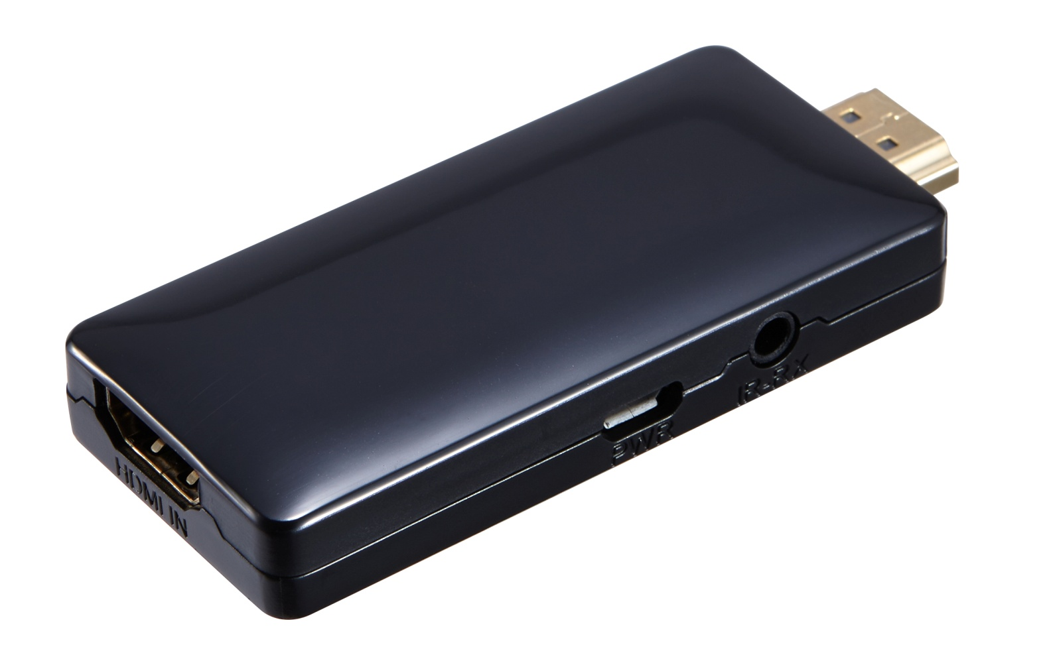

Features:
- Support HDMI 2.0 Version
- Support 3D video format
- Support high resolution up to: 3840x2160/60Hz
- Support highest rate of 6 G and TMDS clock can be up to 600 MHz
- Support 8/10/12 bit deep color
- Built-in IR-RX extension function, (via the IR-TX of HDMI splitter to receive the IR command)
- Support AWG26 HDMI standard cable: When resolution is 3840x2160/30Hz, input distance up to 30 meters.
- 5V power supply. (Normally, the product does not require power supply)

Specifications:
HDMI version ………………………………...........................……. HDMI 2.0
HDMI resolution ……….......………..……….…………up to 3840*2160/60Hz
Support video format ……………………………………8/10/12bit Deep color
Support audio format…...…….DTS-HD/Dolby-trueHD/DTS/Dolby-AC3/DSD
Max bandwidth……………………………………..…………………….600MHz
Max baud rate……………….…….……………...………………………..6Gbps
Input cable distance.……………………….(3840x2160/30Hz) ≤30m,AWG26 HDMI standard cable
Max working current……………………………………...……….……....300mA
Operating Temperature range………………....…..….....……(-15℃ to +55℃)
Operating Humidity range..........................5%to90%RH (No Condensation)
Dimension (L x W x H)…………….......…...............………….80x33x13 (mm)
Weight…….…..……………………..........………..…….……………………22g

Physical Connection Showing Picture:
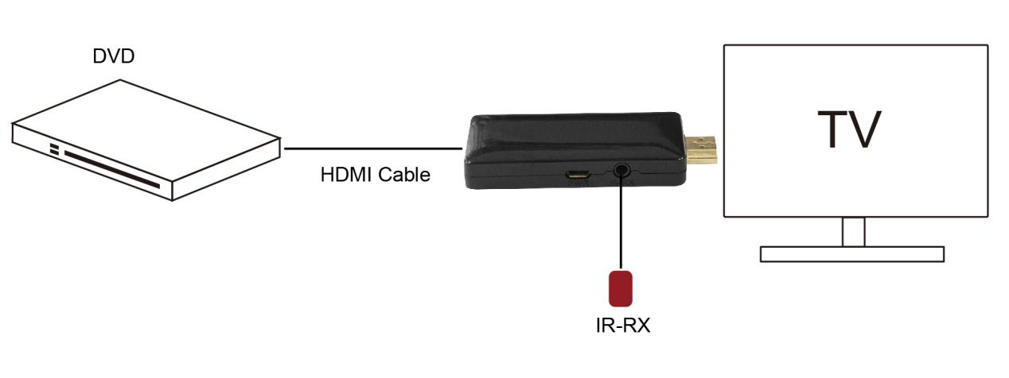

Connection and Operation:
- Connect the HD source to the repeater input with one HDMI cable
- Inset the HDMI repeater to the HDMI input port of the displays
- Inset the IR-RX cable to the IR-RX port of the repeater
- Charge the repeater via Mirco USB cable.

Note:
Since the cable is too long will lead to pressure, the HDMI cable will have insufficient power for some signal source. At this time,it need to power the repeater via Mirco USB cable to make sure the repeater can work properly.

Packageinclude :
- HDMI repeater
- Micro USB cable
- User Manual

