HDMI Splitter
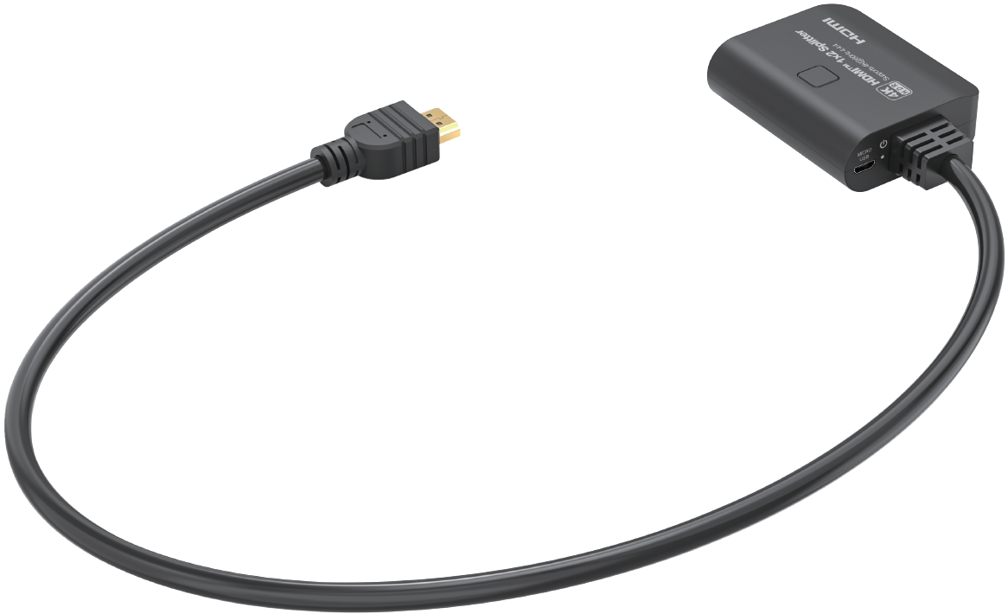
Quick Start Guide

What’s included
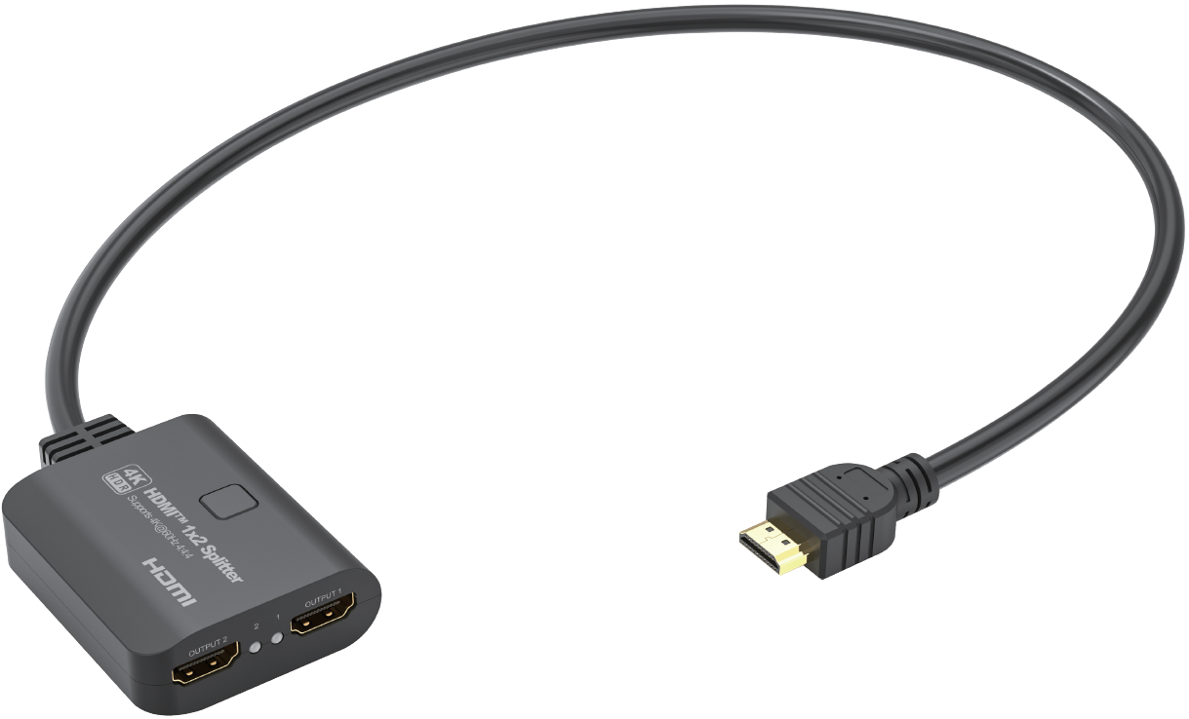
Main Unit
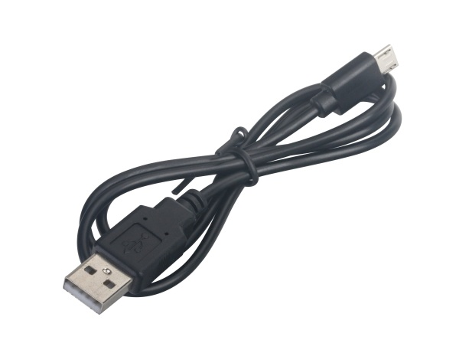
USB Power Cable

Ports and Interfaces
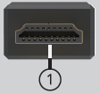
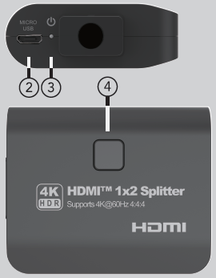
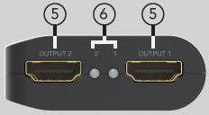

1. HDMI IN: HDMI INPUT Male Port with fixed HDMI cable
2. MICRO USB: USB DC 5V Input
3. POWER: Power LED
4. RESET: USB DC 5V Input
5. OUTPUT 1-2: HDMI Output 1-2 port
6. OUTPUT 1-2: HDMI Output 1-2 LED Indicator

Connection Diagram
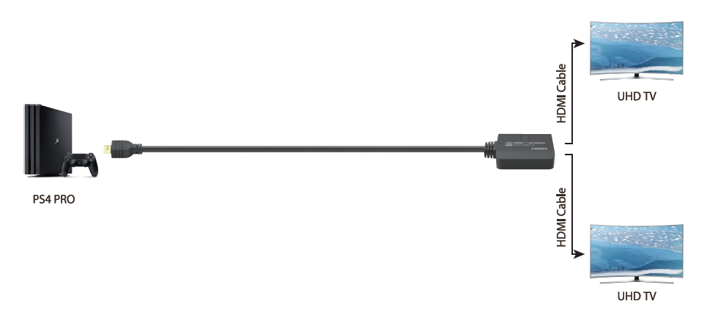

Introduction
The HDMI™ 4K splitter 1x2 with pigtail lets you share two HDMI™ displays or projectors with an HDMI-enabled audio / video source device. With support for Ultra HD (4K@60Hz) the HDMI™ splitter ensures astonishing picture quality, four times the resolution of HD 1080p@60 Hz. The 4K splitter is also backward compatible with previous HDMI™ revisions, supporting 1080p / 720p HDMI™ video resolution devices. Even if you don't require 4K video today, the HDMI™ 4K Splitter 1x2 ensures you'll be ready to take advantage of tomorrow's display technology. With one fixed 0.6 meters HDMI™ cable (pigtail), this splitter is cost-effective and time-saving.

Features
* Support downscale function means the product can downscale the input 4K resolution to 1080p by the FHD (1080p) displays and 4K resolution to the 4K displays simultaneously.
* Support full 3D video format
* Support high resolution up to 4K@60Hz YUV 4:4:4
* Support HDCP 2.2 and HDCP 1.4
* Support High Dynamic Range (HDR) video
* Support 600MHz/6Gbps per channel (18Gbps all channels) bandwidth
* Support 12bit per channel (36bit all channels) deep color
* Support uncompressed audio such as LPCM
* Support compressed audio such as DTS, Dolby Digital (including DTS-HD Master Audio™ and Dolby TrueHD)

Specification
Input Ports | HDMI x 1
Output Ports | HDMI x 2
Vertical Frequency Range | 50/60Hz
Video Amplifier Bandwidth | 6.0Gbps/600MHz per channel(18Gbps all channels)
Interlaced(50&60Hz) | 480i,576i,1080i
Progressive(50&60Hz) | 480p,576p,720p,1080p,4K@24/30Hz,4K@50/60Hz
Limited Warranty | 1 Year Parts and Labor
Operating Temperature | 0℃ to 70℃
Storage Humidity | 5% to 90% RH non-condensation
Power Supply | USB Power Cable
Power Consumption (Max) | 5W
Splitter Unit Cert | FCC, CE, RoHS
Power Supply Cert | FCC, CE, RoHS
Power Adapter Standard | US, EU, UK, AU Standard etc.
Dimension(LxWxH) | 65x54.5x20.5mm
Net Weight | 92g
Material | ABS
User Manual | English Version
Note: Specifications are subject to change without notice.

Troubleshooting

Problems | Causes | Solutions
Power light is off and product is not working | Is the USB power cable properly connected and the power on/off button is on | Please check if the power adapter is connected properly and switch on the power on/off button
Screen splash | HDMI cable may not be HDMI 2.0 specification or the cable is too long | Please use the standard HDMI 2.0 cable, the output cable length does not exceed 5M 4K/60Hz 4:4:4, 4K@30Hz/1080p can reach to 10M
No picture out only sound out or output pink screen | Maybe the displays can’t support the resolution or the HDCP | Change a lower resolution of the input HDMI signal to check whether this issue or not; if not, maybe the customer should change a non-HDCP input source or HDCP compliant displays or devices
No picture out to a FHD TV when connecting a 4K@60Hz source, and have normal picture to the 4K HDR supported TV at the same time | Maybe the downscaler function can`t support the input signal, such as 4K@60Hz 4:2:2 HDR signal(Dolby Vision) or when connect one FHD TV with a fixed 4K@60Hz output device | The downscaler function only support the 4K@60Hz 4:4:4 and 4:2:0(HDR 10) signal downscaler to 1080p signal, or there will not have picture output to the FHD TV, the customer need change a supported downscaler signal input.

Dolby is a trademark of Dolby Laboratories.

The Adopted Trademarks HDMI, HDMI High-Definition Multimedia Interface, and the HDMI Logo are trademarks or registered trademarks of HDMI Licensing Administrator, Inc. in the United States and other countries.

All other trademarks, registered trademarks, or service marks are the property of their respective owners.

