HDMI Switcher
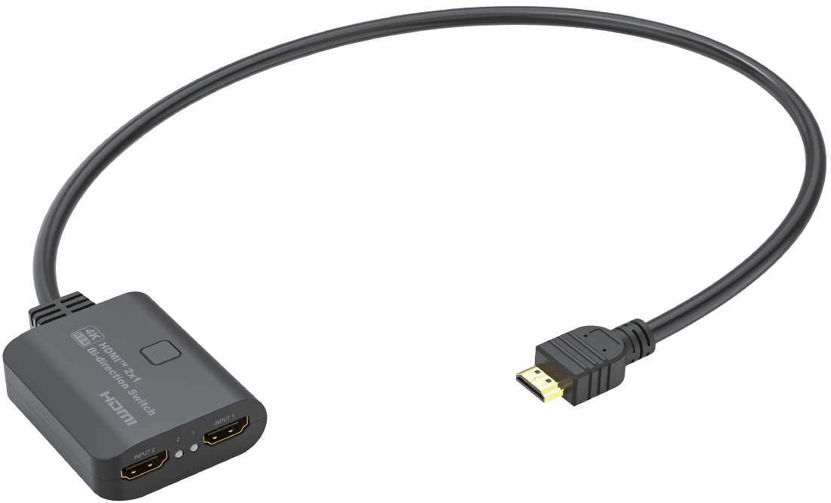
Quick Start Guide

What’s included
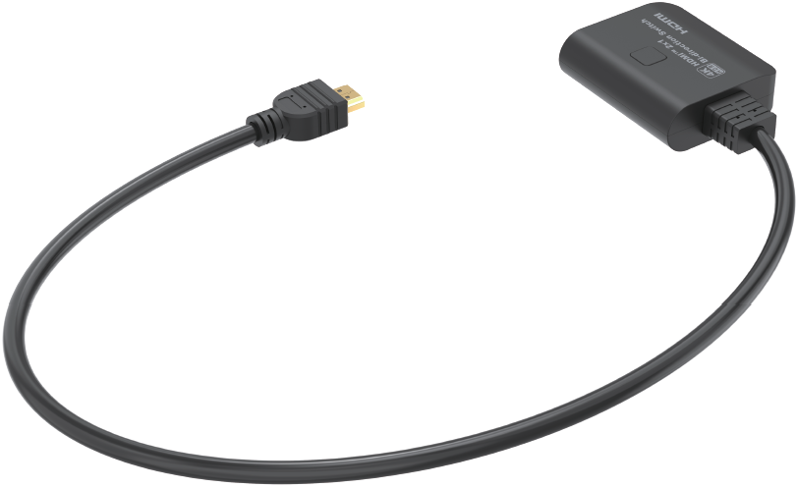
Main Unit

Ports and Interfaces
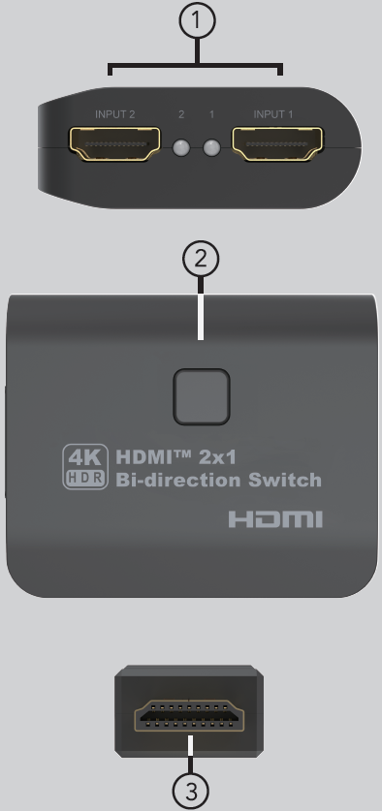

1. 1-2: HDMI Input/output 1-2 LED Indicator；INPUT 1-2: HDMI Output 1-2 port When 1 In 2 Out Mode and HDMI Input Port 1-2 When 2 In 1 Out Mode
2. SELECT: Select the Channel 1 or 2 to Pass-through the HDMI Signal
3. HDMI Male Port: HDMI INPUT Port When 1 In 2 Out Mode and HDMI Output Port When 2 In 1 Out Mode

Connection Diagram
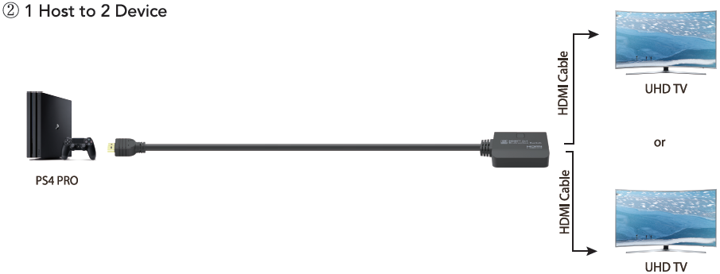

Introduction
This is one device of HDMITM 2 ports bi-direction manual switches. It can easily switch two routes of UHD Source to any one UHD display or projector or distribute one UHD Display or projector to two displays (not synchronously). This newer bi-directional switch adopts integrated IC solution to substantially reduce product power consumption for improved compatibility. For added versatility, the switch can draw power from the input sources via HDMITM Cable. It is very convenient in areas where access to power outlets is limited. With one fixed 0.6 meters HDMITM cable (pigtail), this switch is cost-effective and time-saving

Features
* 2 HDMI-Host to 1 HDMI monitor
* 1 HDMI-Host to 2 HDMI monitors
* Max operation Current: 11mA
* Backward compatible with the HDMI earlier versions
* Support HDCP 2.2 and HDCP 1.4
* Support high definition resolution 4K@60Hz YUV 4:4:4 and Full 3D
* Support 600MHz/6.0Gbps per channel bandwidth (18Gbps all channels)
* Support Consumer Electronics Control
* Support High Dynamic Range (HDR) video
* Manual port selection: Enables you to manually select your HDMI source with easy-to-use panel buttons.
* LED working status indication
* Easy installation & operation: plug and play

Specification
Input Ports | HDMI Male Port x 1（1 in 2 out）/ HDMI x 2（2 in 1 out）/
Output Ports | HDMI x 2（1 in 2 out）/ HDMI Male Port x 1（2 in 1 out）
Vertical Frequency Range | 50/60Hz
Video Amplifier Bandwidth | 6.0Gbps/600MHz per channel(18Gbps all channels)
Interlaced(50&60Hz) | 480i,576i,1080i
Progressive(50&60Hz) | 480p,576p,720p,1080p,4K@24/30Hz,4K@50/60Hz
Limited Warranty | 1 Year Parts and Labor
Operating Temperature | 0℃ to 70℃
Storage Humidity | 5% to 90% RH non-condensation
Power Supply | N/A
Power Consumption (Max) | 5W
Switcher Unit Cert | FCC, CE, RoHS
Dimension(LxWxH) | 65x54.5x20.5mm
Net Weight | 92g
Material | ABS
User Manual | English Version
Note: Specifications are subject to change without notice.

Troubleshooting

Problems | Causes | Solutions
Screen splash | HDMI cable may not be HDMI 2.0 specification or the cable is too long | Please use the standard HDMI 2.0 cable, the input/output cable length does not exceed 1.5M 4K/60Hz 4:4:4, 4K@30Hz/1080p can reach to 4M
Can`t output to two displays at the same time | The product is a bi-direction switcher support 1 in 2 out (not synchronously) and 2 in 1 out | Manual select the most wanted display to show the picture at a time and press the select button to change the next display

Dolby is a trademark of Dolby Laboratories.

The Adopted Trademarks HDMI, HDMI High-Definition Multimedia Interface, and the HDMI Logo are trademarks or registered trademarks of HDMI Licensing Administrator, Inc. in the United States and other countries.

All other trademarks, registered trademarks, or service marks are the property of their respective owners.

