HDMI Extender
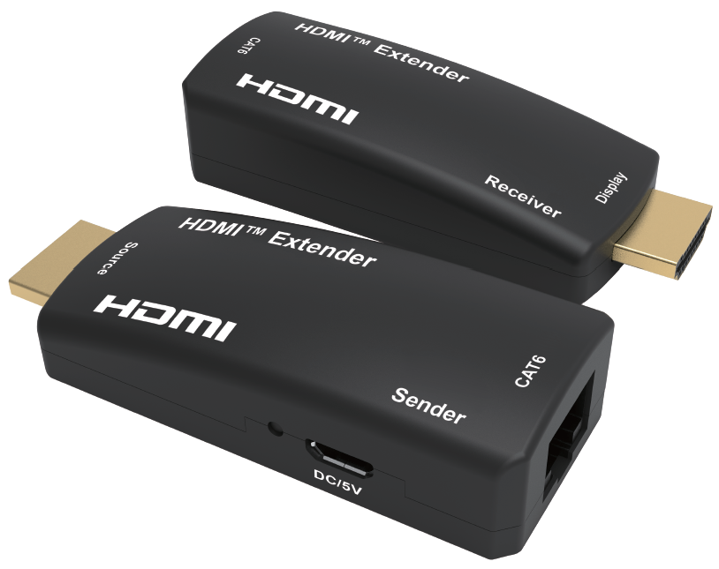
Quick Start Guide

What’s included
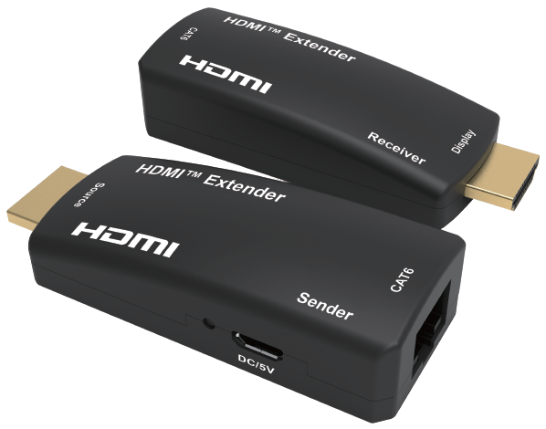
Main Unit
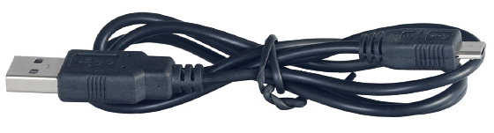
Micro-USB Power Cable x 2

Ports and Interfaces

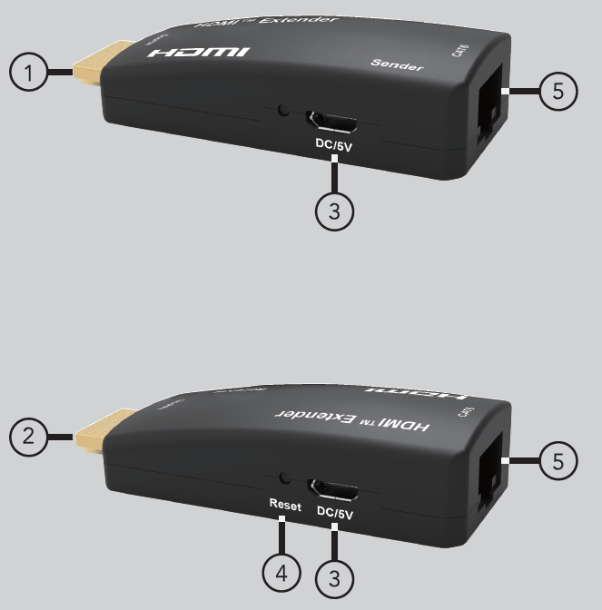
1. Source: Connect to Input Sources via HDMI Male Input Port
2. Display: Connect to Output Devices via HDMI Male Output Port
3. DC 5V: Micro USB Power DC 5V In
5. Reset: Reset at Receiver: function as equalizer
5. CAT6: Connect CAT6 Cable For Extend HDMI Signal Transmission

Connection Diagram
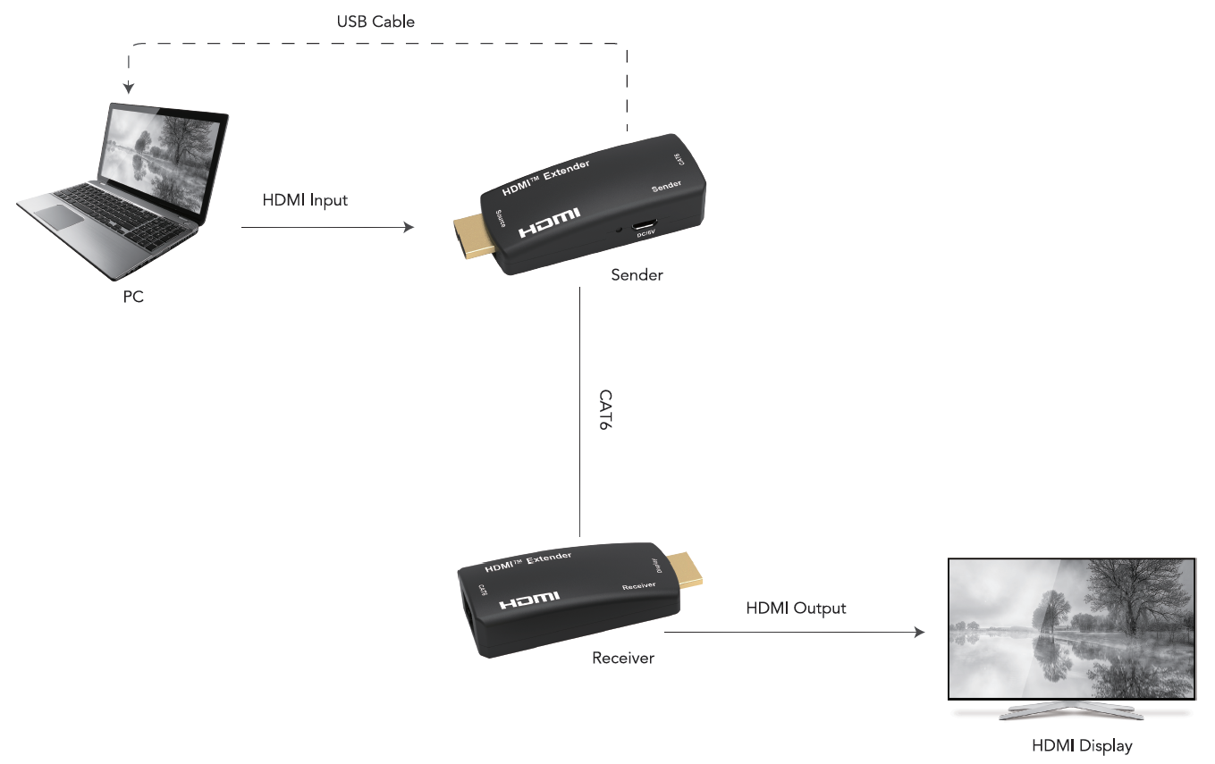

Introduction

The HDMI™ Extender lets you extend HDMI™ audio/video signal by up to 50 meters (164 feet) over single CAT6 cable. The extender kit includes both the local transmitter and remote receiver units, ideal for point-to-point digital signage applications that require high quality HDMI™ video. For perfect performance, the extender comes with a reset function on the receiver, which enables user to adjust the signal to best match the cable length.

Features
* Slim and portable size design, plug and play, without installation
* HDMI over single CAT6 cable transmission up to 50m/164ft
* Supports lossless uncompressed A/V signal transmission
* Signal auto adjustment to match the cable length after press ‘RESET’ button on receiver
* Full HD 1080p transmission to make video image more vivid
* Supports 3D video format
* Both the transmitter and receiver are powered by Micro USB, support receiver powered from transmitter

Specification
Input Ports | HDMI x 1, RJ45 x 1
Output Ports | HDMI x 1, RJ45 x 1
CAT-6 Cable | 50m for 1080p
Vertical Frequency Range | 50/60Hz
Interlaced Resolutions(50&60Hz) | 480i,576i,1080i
Progressive Resolutions(50&60Hz) | 480p,576p,720p,1080p
Limited Warranty | 1 Year Parts and Labor
Operating Temperature | 0℃ to 50℃
Storage Humidity | 5% to 90% RH non-condensation
Power Supply | Powered via micro-USB ports
Power Consumption (Max) | 5W
Extender Unit Cert | FCC, CE, RoHS
Dimension(LxWxH) | 62x27x17mm
Net Weight | Sender:18g; Receiver:17g
Material | ABS
User Manual | English Version

Troubleshooting

Problems | Causes | Solutions
No signal or picture flicker | The EQ value is not match with the UTP cable length | Press the reset button on receiver to change the EQ value to match the UTP cable length, if works the picture will be ok
Press the reset button to change the EQ value, the output remain no signal | Maybe the cable quality is not good as recommend | Please change a good quality cable as recommend or a short cable no less than 1m
Cable and EQ setting is recommended, product doesn`t work | Maybe the power supply is not enough | Please connect power supply of both side with the micro-USB power cable
Dolby is a trademark of Dolby Laboratories.

The Adopted Trademarks HDMI, HDMI High-Definition Multimedia Interface, and the HDMI Logo are trademarks or registered trademarks of HDMI Licensing Administrator, Inc. in the United States and other countries.

All other trademarks, registered trademarks, or service marks are the property of their respective owners.

